1. Packages

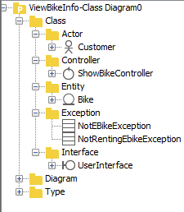

1. Class diagram

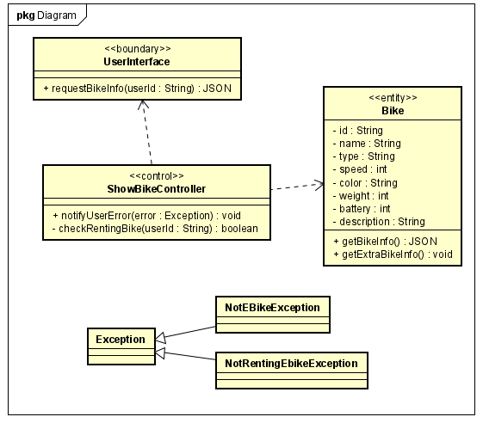

1. Class specification
2. Class Bike

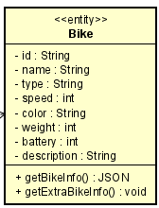

***Attributes:***

|  |  |  |  |  |
| --- | --- | --- | --- | --- |
| # | Name | Data Type | Default value | Description |
| 1 | id | String | Null | // |
| 2 | name | String | Null | // |
| 3 | type | String | Null | // |
| 4 | speed | int | Null | // |
| 5 | color | String | null | // |
| 6 | weight | int | Null | // |
| 7 | battery | String | Null | // |
| 8 | description | String | Null | // |

***Operations:***

|  |  |  |  |  |  |
| --- | --- | --- | --- | --- | --- |
| # | Name | Return Type | Description | Parameter | Exception |
| 1 | getBikeInfo | Json | get the bike attributes | null | null |
| 2 | getExtraBikeInfo | Json | get Ebike info, only work with Ebike | null | NotEBikeException-If bike is not Ebike |

***Method:***

None

***State:***

None

1. Class UserInterface

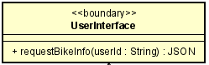

***Attributes:***

|  |  |  |  |  |
| --- | --- | --- | --- | --- |
| # | Name | Data Type | Default value | Description |

***Operations:***

|  |  |  |  |  |  |
| --- | --- | --- | --- | --- | --- |
| # | Name | Return Type | Description | Parameter | Exception |
| 1 | requestBikeInfo | Json | Get the info of the renting bike | userId-id of the requester | null |

***Method:***

None

***State:***

None

1. Class ShowBikeController

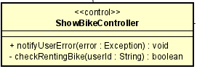

***Attributes:***

|  |  |  |  |  |
| --- | --- | --- | --- | --- |
| # | Name | Data Type | Default value | Description |

***Operations:***

***None***

***Method:***

|  |  |  |  |  |  |
| --- | --- | --- | --- | --- | --- |
| # | Name | Return Type | Description | Parameter | Exception |
| 1 | checkRentingBike | boolean | Check if requester user renting a bike | userId | NotRentingBikeException-if the user not renting a bike |
| 2 | notifyUser | void | Notify user if an error occurs | error | null |

***State:***

None